HADWEN P.P.G. NEWSLETTER
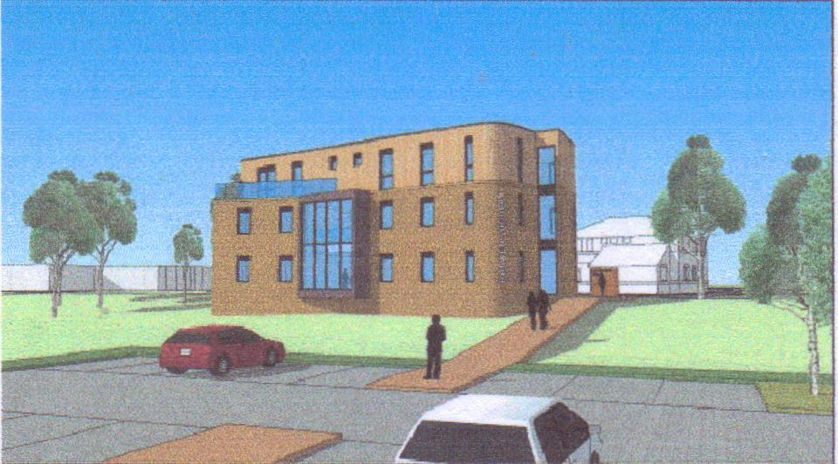

Hi everybody an apology for the lack of newsletters since last March but with the virus we were only able to hold a zoom meeting in Sept and the minutes of this meeting are available on the Practice website.
As you can imagine the Practice is working hard to help those that need help during this crisis so please be aware of the problems they are facing during these difficult and stressful times.
I have just had my jab at Rosebank and found the staff there very kind and caring and put me at ease straight away. Car park attendants are there to show you the parking bays that have been designated for vaccination patients and there are several disability spots by front door.
The next meeting will possibly be March but no date has yet been set.
I have decided to step down from the chair after 6 years and although I will miss it, I feel it is time for a new face and therefore I am happy to announce that Sam Dunn has taken over the chair.
I know that she will have the heart of the patients in her mind so please contact her as you have contacted me in the past with your views and comments.
Her email is sam.dunn.hadwenppg@gmail.com
Once again thank you for your past input and stay safe and well.
Regards
Pat McCann

